Using the Accomplishments/Workload Timeline Visio Template

Editing the Arrows and Circles (objects): Right-click to open the editing menu and select “Format Shape.” This brings up the formatting tab on the right of your screen.

Fill is the color of the object.

Click the paint bucket to choose from a variety of colors.

Line is the shape’s outline. The default for arrows is no outline; the default for circles is a solid black outline.

You can experiment with these additional settings to suit your style.

Change the caps on your arrows as needed to show start, finish, or ongoing activities. You can also change the style and shape of the arrows with these settings.

Add More Arrows or Circles:
-Right-click on the object and select “Copy”
-Right-click where you would like to create a new object, and select “Paste”
-Drag and re-size the new object as needed.

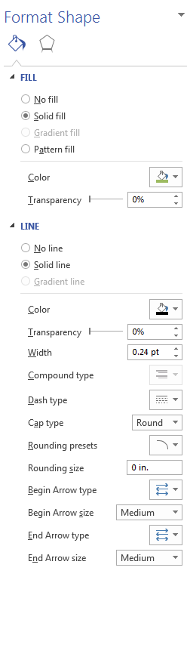

Changing the Text of an Object:
Double-click in the text to edit. Font and size can be edited in the “Home” tab as with any Word document.
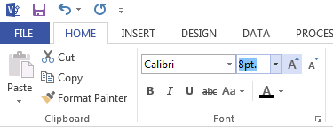
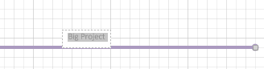

Use extra spaces to adjust the positioning of the label on the line. Spaces before your text will push it towards the right, after your text will push it to the left.

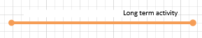

Here, spaces to the left of the label text have pushed it near the end of the arrow (gridlines will not show when printing). This can be useful for your layout, when multiple activities are “stacked” together, you can de-clutter the text.

If this trick doesn’t work, use a text box instead of the label. You can drag the text box exactly where you need it.
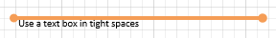
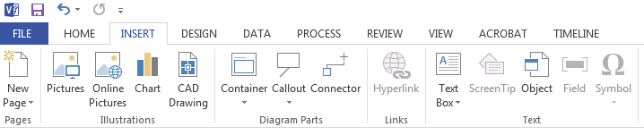

Adjusting the Size of an Object:
-Click anywhere in the object.
-For circles adjust by height, width, or entire circle by clicking and dragging on the white squares.
-For arrows, click and drag the white boxes at either end to lengthen or shorten the line.

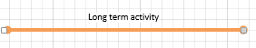
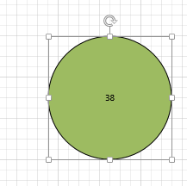

Editing the Timeline:
Right-click to open the editing menu and select “Configure Timeline.” From this menu you can edit the start and end dates, time scale, and time format.

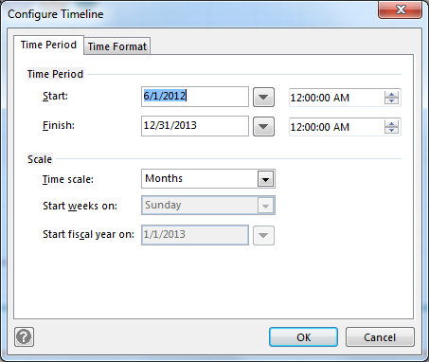

You can also change the date format by right-clicking on the timeline and selecting “Change Date/Time Formats.”

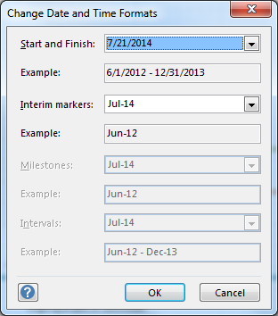

Change the Orientation and Paper Size:

The template is set to print landscape on 8.5”x14” (legal) size paper. To adjust the size and orientation, use the “Design” tab. Here, you can also find pre-set color schemes to use.

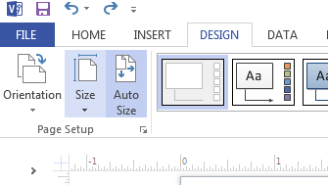

Questions?
Contact:
Carla Arbagey
E-Resources Librarian
University of California, Riverside
carlar@ucr.edu
(951)827-5346

